**Project Report: Ticket Flix**

**1. INTRODUCTION**

**1.1 Project Overview**

Ticket Flix is envisioned as a feature-rich, scalable, and intuitive web-based platform designed to completely transform the movie ticket booking experience across India. It sets out to bridge the evident gap between modern urban multiplexes and the more traditional, regional single-screen theaters. With a strong emphasis on inclusivity and accessibility, the platform presents a sleek and user-centric interface, localized functionalities tailored to diverse user groups, and intelligent automation that simplifies operations for both users and theater managers.

Built using the modern and efficient MERN (MongoDB, Express.js, React.js, Node.js) stack, Ticket Flix introduces a comprehensive solution that integrates real-time seat availability, seamless payment options, multi-language support, and a robust backend theater management system. Altogether, it offers a new benchmark in online ticketing systems, capable of scaling across the country and enhancing the cinema-going experience.

**1.2 Purpose**

The principal aim behind the development of Ticket Flix is to provide a unified and easily accessible movie ticketing ecosystem that resolves the fragmentation currently plaguing the Indian cinema landscape. Existing systems often lack the reach, accessibility, and clarity that users expect—particularly in smaller cities and towns. Ticket Flix intends to solve this by enhancing the overall booking experience for users and simultaneously improving operational efficiency for theater owners. Through real-time data access, customizable interfaces, and secure, scalable infrastructure, Ticket Flix empowers both consumers and cinema administrators.

**2. IDEATION PHASE**

**2.1 Problem Statement**

During the early ideation stage, a series of stakeholder discussions and user feedback sessions revealed key challenges in existing ticketing platforms. Many users expressed frustration over limited access to local theaters, confusing user interfaces, and an overall lack of transparency—especially concerning seat availability. These issues were more pronounced in Tier 2 and Tier 3 cities, where manual ticket booking still prevails.

Furthermore, theater owners in these regions are often constrained by outdated infrastructure, leading to inefficient management and dissatisfied customers. These compounded issues underscored the necessity of a streamlined, inclusive, and intelligent solution that could bridge the urban-rural divide in digital movie booking.

**2.2 Empathy Map Canvas**

An empathy map is a simple, easy-to-digest visual that captures knowledge about a user’s behaviours and attitudes.

It is a useful tool to helps teams better understand their users.

Creating an effective solution requires understanding the true problem and the person who is experiencing it. The exercise of creating the map helps participants consider things from the user’s perspective along with his or her goals and challenges.

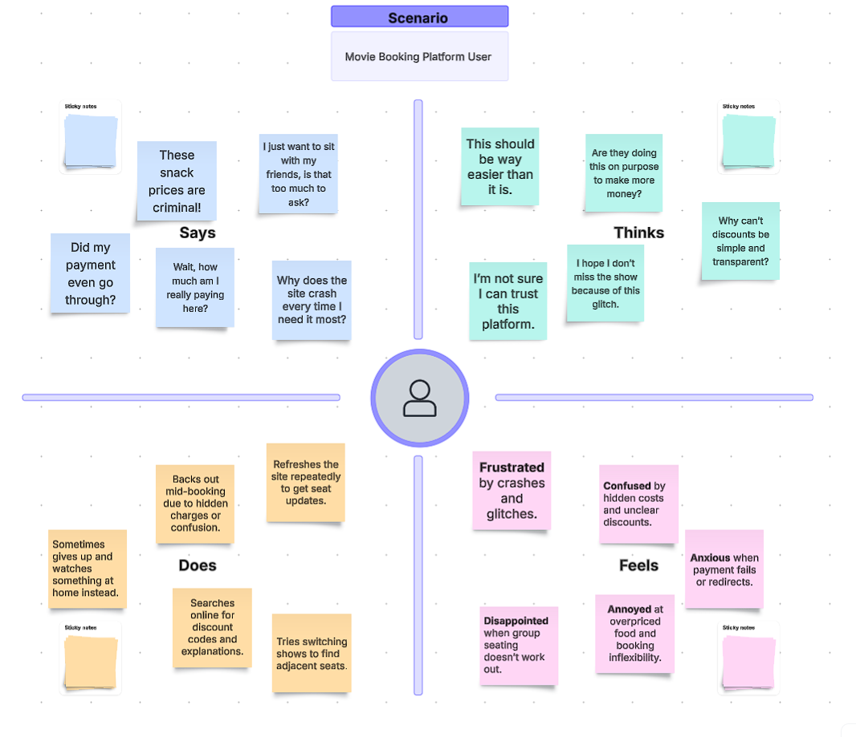

**2.3 Brainstorming**

The brainstorming phase featured collaborative efforts involving students, developers, and theater owners to ensure the solution addressed both consumer and operational pain points. A wide array of ideas surfaced during these sessions, such as:

* Support for multiple regional languages
* Seamless integration with single-screen cinema venues
* Interactive and dynamic seat selection maps
* AI-powered recommendation systems
* Blockchain-based systems for ticket verification
* Customer loyalty and rewards programs
* Partnering with local businesses for bundled promotions

Each idea was evaluated on the basis of feasibility, impact, and potential value to end-users. This led to a curated set of features that formed the foundation of Ticket Flix. 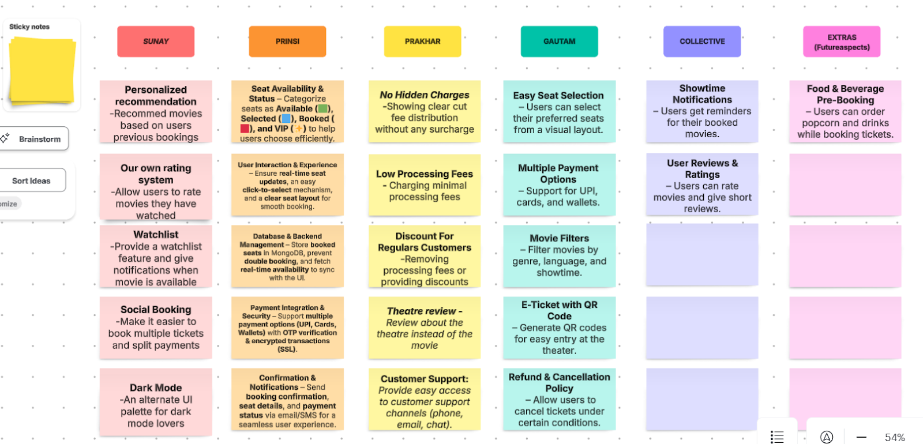

**3. REQUIREMENT ANALYSIS**

**3.1 Customer Journey Map**

The user journey on Ticket Flix begins with discovering a new movie, followed by browsing showtimes and available theaters. Users can then select their preferred seats, proceed with a secure booking process, and receive their digital tickets. On the administrative end, theater owners utilize a dedicated dashboard to manage show listings, seat inventories, and sales analytics. This journey was meticulously designed to reduce user friction and boost confidence at every step.

**3.2 Solution Requirements**

To meet the demands identified in the analysis phase, the platform’s functional requirements include:

* User registration and secure login
* Real-time updates on movie listings and seat availability
* Payment gateway integration for smooth transactions
* QR-code-based digital ticket validation
* Theater admin panel for operational control
* Responsive user interface compatible with mobile and desktop devices
* Full multi-language support for broader accessibility

Non-functional requirements were also critical and included:

* High system availability and responsiveness, especially during peak hours
* Strong security protocols for transaction safety
* Horizontal scalability to support growing user loads across different regions

**3.3 Data Flow Diagram**

The system’s data flow is streamlined and efficient:

* The user initiates requests via the frontend
* These are processed by a React-based application, which interacts with the Express.js API
* The API layer communicates with MongoDB to retrieve or update data related to users, movies, and seats
* Redis is used for caching frequently accessed data, improving lookup speed
* Payments are handled securely through Razorpay
* Admin actions are reflected in real time, updating both the database and frontend interface

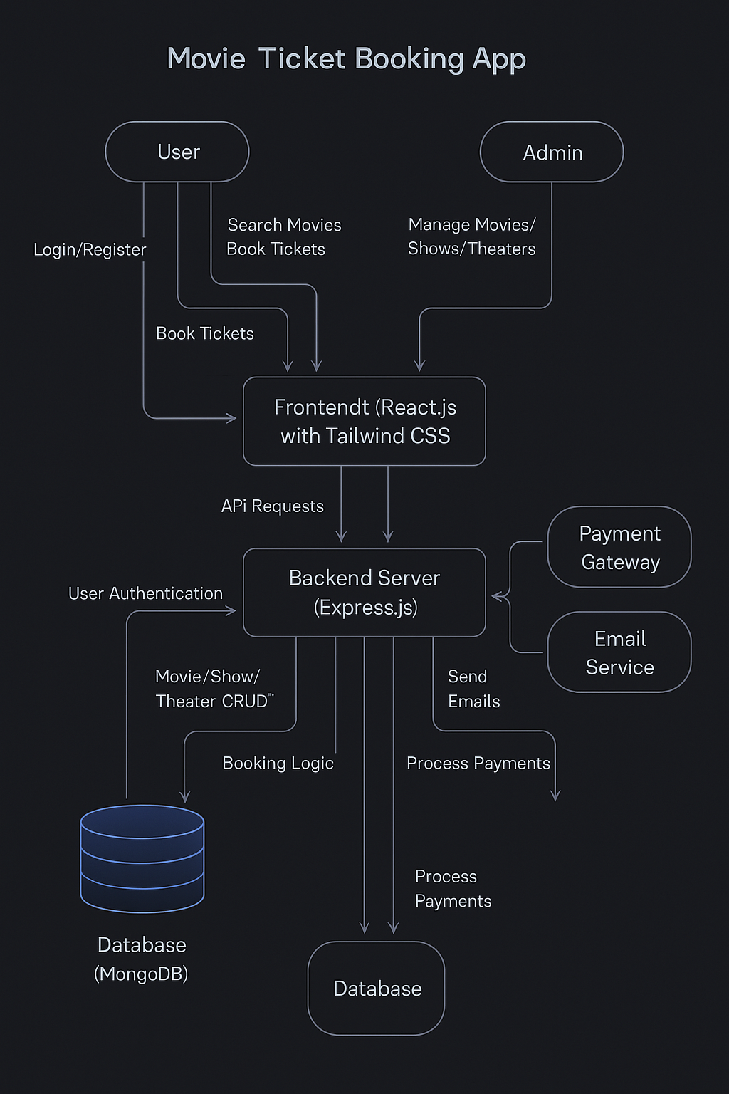

**3.4 Technology Stack**

The technology choices reflect a modern and scalable architecture:

* Frontend: React.js with Tailwind CSS for a responsive and clean UI
* Backend: Node.js and Express.js for handling API logic
* Database: MongoDB Atlas for flexible and scalable data management
* Caching: Redis for optimizing speed and performance
* Authentication: Firebase Auth and JWT for secure session handling
* Hosting: AWS (EC2, S3, CloudFront) for deployment and content delivery
* CI/CD: GitHub Actions and Docker for continuous integration and deployment
* Payment: Razorpay API for handling transactions
* Analytics: Google Analytics and LogRocket for monitoring and user behavior insights 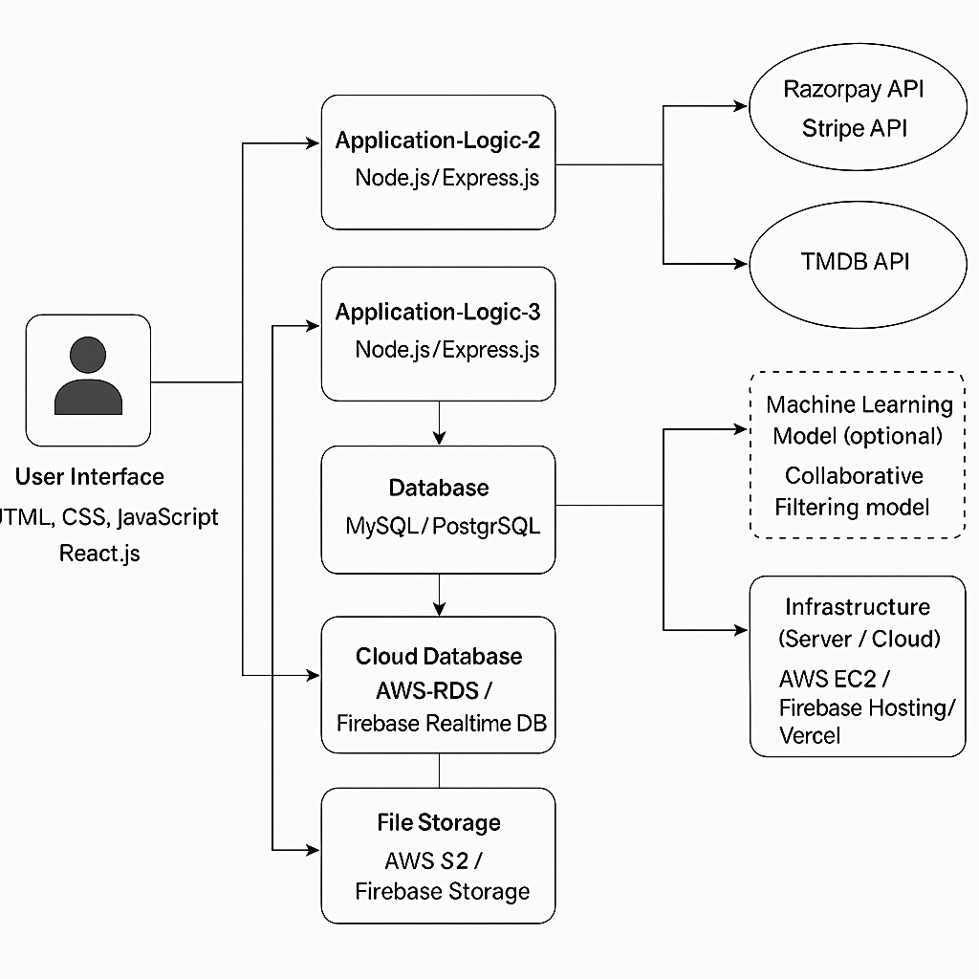

**4. PROJECT DESIGN**

**4.1 Problem Solution Fit**

Ticket Flix was deliberately crafted to address the most pressing pain points associated with online ticket booking. With real-time updates, a mobile-first approach, and localized theater integration, the platform delivers a tailored solution for both metropolitan and rural audiences. Behavioral insights gathered during the empathy mapping and ideation phases were key to shaping this solution, ensuring that user expectations were met with technical precision and thoughtful design.

**4.2 Proposed Solution**

The final solution comprises:

* A centralized web portal for discovering and booking movie tickets
* A comprehensive admin panel to help theaters manage operations
* A blockchain-backed system for validating ticket authenticity
* AI-based recommendation logic powered by MongoDB aggregation
* A responsive, multilingual interface catering to a diverse user base
* Integrated payment workflows that are simple and secure
* Loyalty rewards to promote repeated usage and user retention

**4.3 Solution Architecture**

* The architectural framework consists of:
* A single-page React frontend, consuming RESTful APIs
* Modular routing and middleware in the Express.js backend
* MongoDB serving as the primary data source
* Redis enhancing performance through session and seat cache management
* JWT providing secure user authentication and session management
* Third-party payment layers for processing bookings
* A detailed admin dashboard with analytics, show controls, and revenue tracking 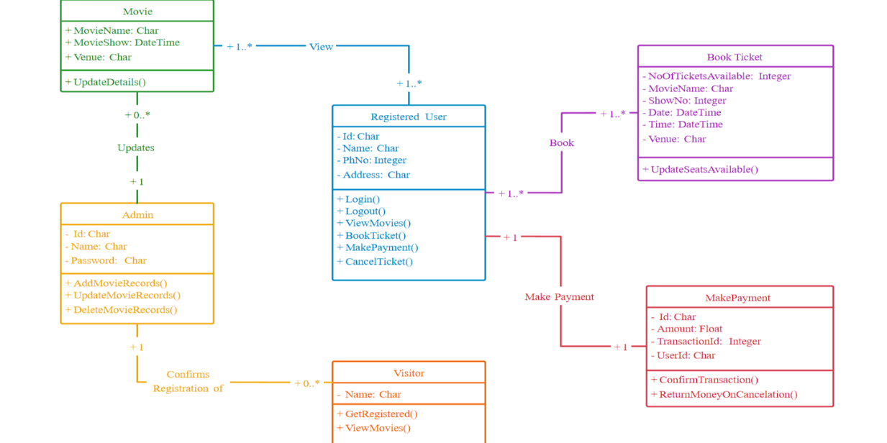

**5. PROJECT PLANNING & SCHEDULING**

**5.1 Project Planning**

The development process was strategically divided into four major sprints to ensure timely and organized progress:

1. Sprint 1: Setup of the frontend framework, user authentication modules, and basic routing
2. Sprint 2: Implementation of movie listing and theater management modules, along with MongoDB data connectivity
3. Sprint 3: Development of seat selection logic, real-time booking capabilities, and integration with the payment gateway
4. Sprint 4: Final deployment including the admin dashboard, blockchain features, and system testing

All tasks were tracked using Gantt charts and milestone planning tools to ensure efficient task distribution and team accountability.

**6. FUNCTIONAL AND PERFORMANCE TESTING**

**6.1 Performance Testing**

Performance testing was executed according to the standards outlined in the User Acceptance Testing (UAT) functional specification document. Key benchmarks included:

* Load testing for high-volume seat booking scenarios
* API latency under simulated stress conditions
* Speed and reliability of payment processing
* Robust recovery mechanisms for interrupted or failed sessions
* Adherence to web security best practices, including the OWASP Top 10 standards

Testing tools such as Postman, JMeter, and Google Lighthouse were employed to evaluate backend endpoints, UI responsiveness, and mobile performance across various conditions.

**7. RESULTS**

**7.1 Output Screenshots**

The project includes visual snapshots of core user and admin interfaces such as:

* Landing page

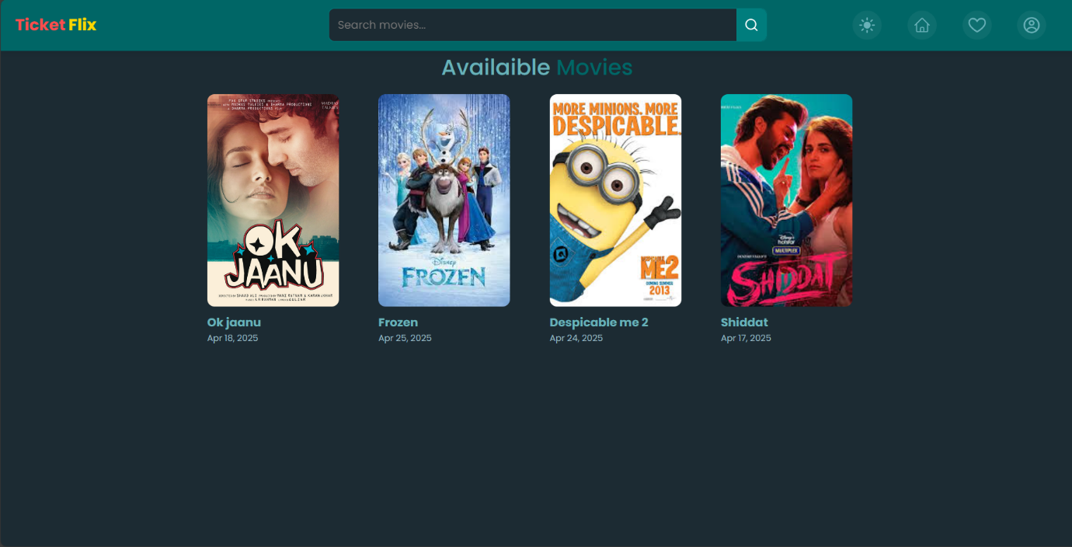

* Movie browsing interface

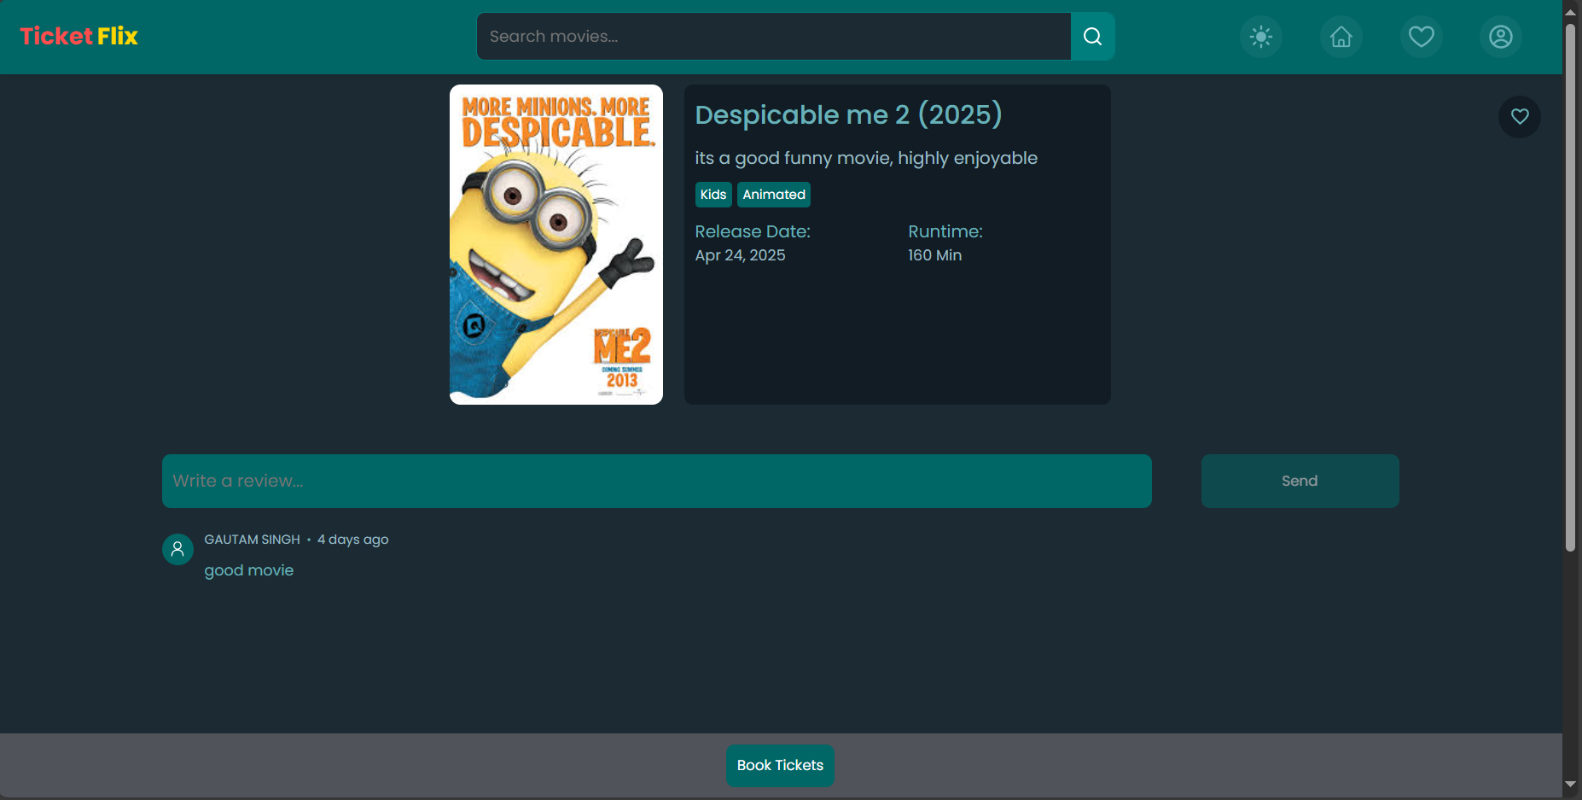

* Interactive seat map

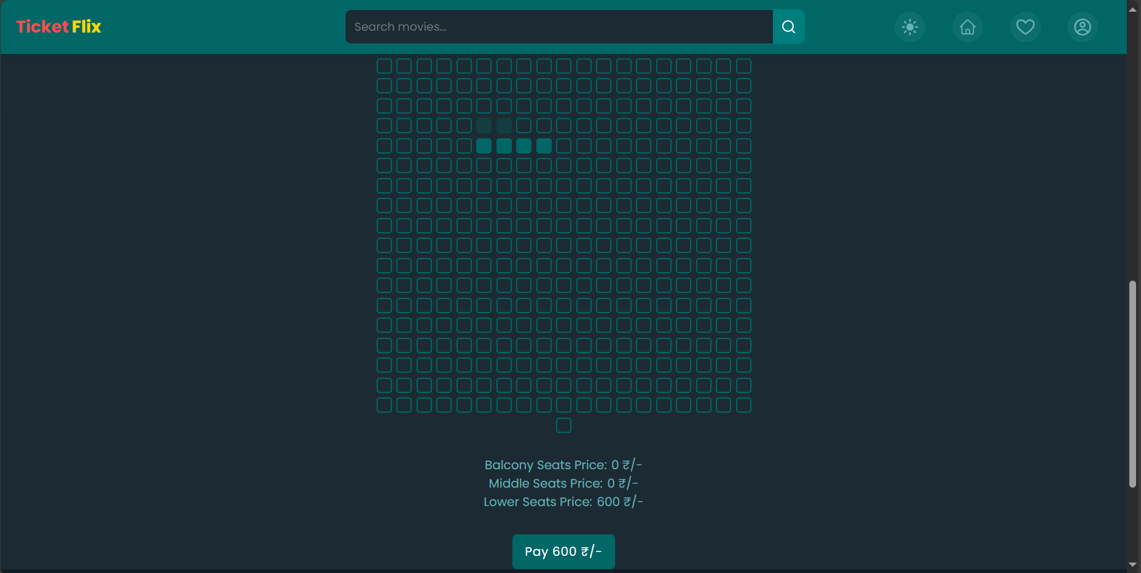

* Payment success confirmation

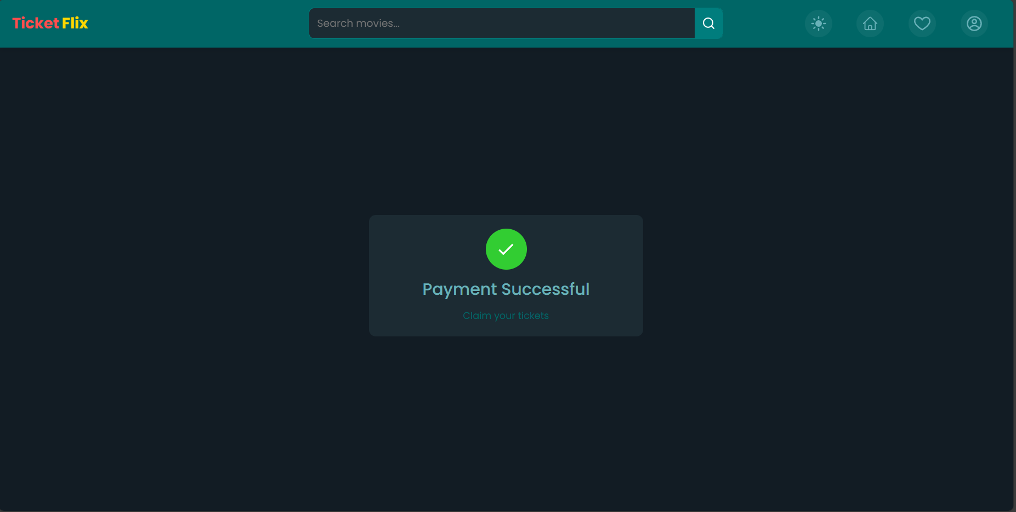

* Admin dashboard featuring analytics and control panels

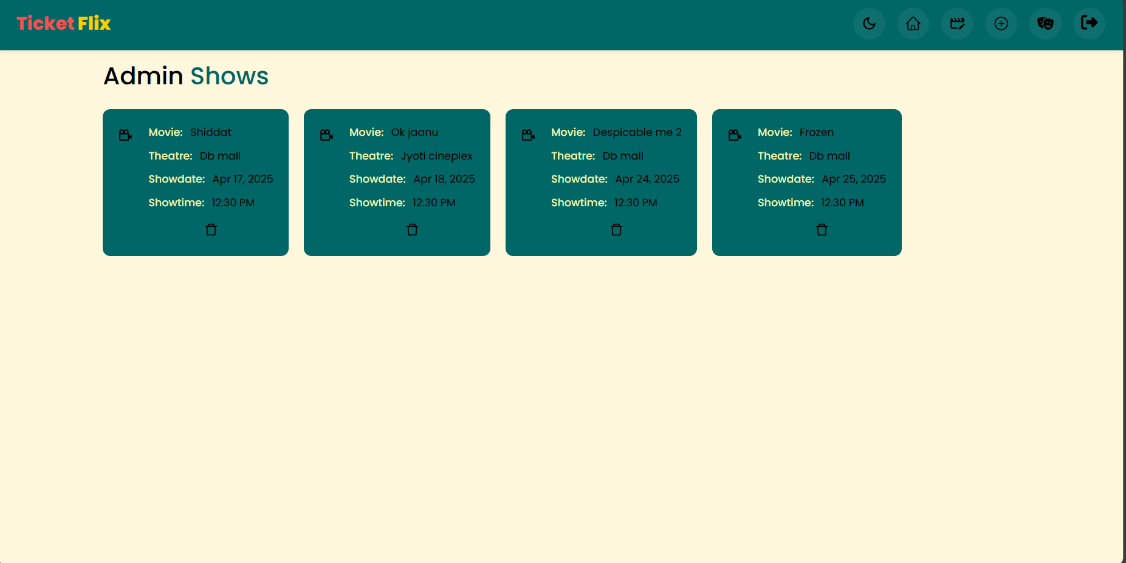

**8. ADVANTAGES & DISADVANTAGES**

Advantages:

* Inclusive design catering to diverse demographics
* Real-time seat and theater management
* Scalable architecture for national deployment
* Secure transactions and blockchain verification

Disadvantages:

* Initial theater onboarding requires training
* Internet dependency may affect remote areas
* Operational costs for SMS/email notifications

**9. CONCLUSION**

Ticket Flix serves as a powerful demonstration of how thoughtful design and modern technology can converge to solve a widespread, real-world problem. By bridging the digital gap in the cinema industry, the platform enables a smooth, reliable, and enjoyable booking experience for users, while offering powerful tools for theaters to streamline their operations. Its flexibility, security, and scalability make it a promising solution capable of reshaping the future of movie ticketing in India.

**10. FUTURE SCOPE**

Looking ahead, Ticket Flix can evolve further by introducing:

* Native mobile apps for Android and iOS platforms
* OTT platform tie-ins for live premiers and hybrid releases
* AI-powered dynamic pricing strategies
* Voice-activated booking via assistants like Alexa or Siri
* Intelligent chatbots to handle user queries and support

**11. APPENDIX**

Source Code: https://github.com/SunayNag/Movie-ticket-Booking.git

Dataset Link: Not applicable (data is dynamic/live)

GitHub & Project Demo Link: https://github.com/SunayNag/Movie-ticket-Booking.git

Phase Wise Documentation: https://github.com/SunayNag/Movie-ticket-Booking/tree/main/TicketFlix%20PhaseWise%20and%20Final%20Documentation